Report of the New Government& Judicial Building Commission
Presented to the Honorable Mayor Teresa Tomlinson
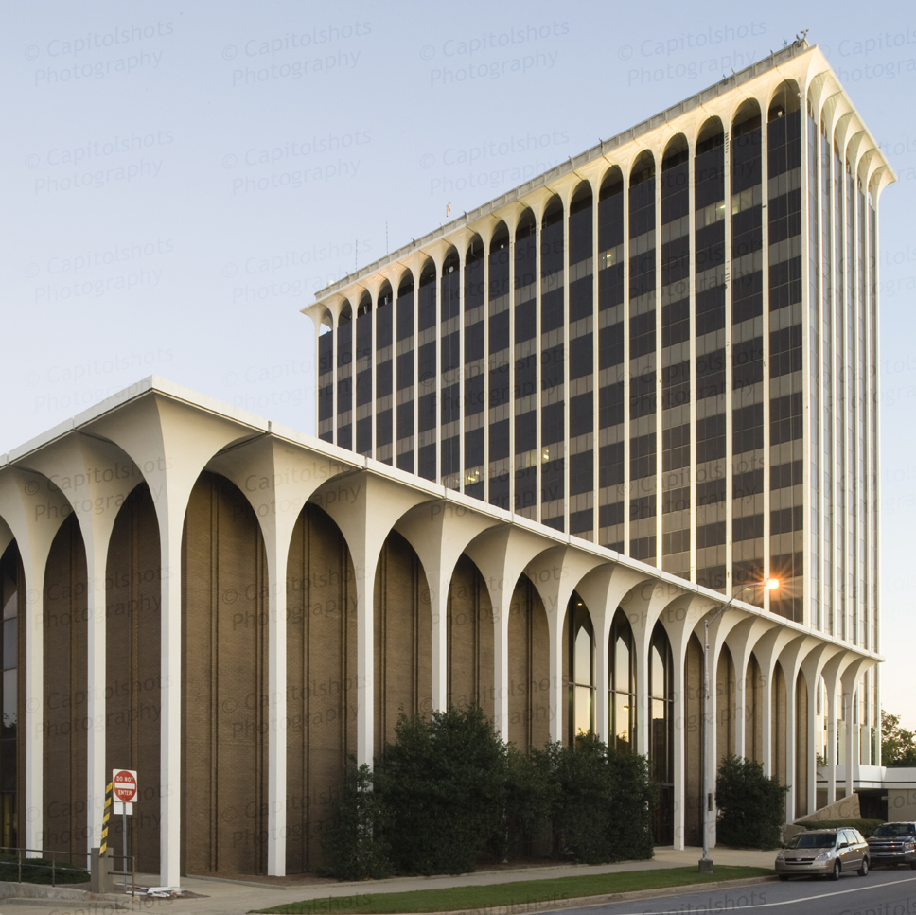

Table of Contents
- New Government & Judicial Building Commission Members………….………………………………………………………….3
- Statement of Objective ……………………………………………….4
- Methodology…………………………….…………………………………4
- The Government Center Then and Now……………………….5
- Existing Conditions And System Concerns...………………….6
  - Security Threats………………………………………………………7
  - Systems Failures……………………………………………………..8
- Space Needs Assessment………………………………………………9
- Renovation Versus New Construction…………………………10
- Architectural and Historical Significance of the Government Center…………………………………………………………………………10
- Proposed Funding Options………………………………………….11
- Conceptual Site Studies………………………………………………12
- Initial Citizen And User Input………………………………………13
- Three Building Proposals…………………………………………….15
- Public Forums……………………………………………………………..20
- Commission Selection of Proposed Option………………….22
- Appendix Content……………………………………………………….24

New Government & Judicial Building Commission Members

Ann Hardman Clerk, Superior Clerk
Ben Richardson Judge, State Court
Brian Anderson Chamber of Commerce
Capt. Todd Turner Fire/EMS
David Helmick Attorney
Donna Tompkins Sheriff
Elizabeth Barker Historic Columbus
Evelyn Pugh Mayor Pro Tem
Gary Allen Columbus Council
Gil McBride Chief Judge, Superior Court
Isaiah Hugley City Manager
Jimmy Elder Reverend, First Baptist Church
Joy Norman Director of Center for Accommodation & Access, CSU
Julia Slater District Attorney
Kenneth Followill Senior Judge, Superior Court
Kristen Miller Zohn Citizen
Lisa Goodwin Deputy City Manager
Medley Hayes Attorney
Mike Massey Security, Sheriff’s Office
Natalia Naman Temesgen Citizen
Norman Easterbrook Citizen
Pam Hodge Deputy City Manager
Paul Pierce Producing Artistic Director, Springer Opera House
Robert Anderson Liberty District
Richard Bishop Citizen
Ronzell Buckner Citizen
Skip Henderson Columbus Council
Teresa Tomlinson Mayor
Walker Garrett Columbus Council

The New Government & Judicial Building Commission (Commission) was ably assisted by experts in their fields to include architects Hecht-Burdeshaw and 2WR, Historic Columbus Foundation and Columbus Consolidated Government (CCG) staff(including Engineering, Buildings and Code and Finance personnel).

Statement of Objective
The purpose of the Commission is to review and consider the existing conditions at CCG’s current Government Center, located at 100 – 10th Street, and to make recommendations on whetherand how to appropriate funds to better these conditions.
Methodology
The Commission assessed the current condition of the Government Center, utilizing CCG staff and stakeholder input.The Commission met regularly in two-hour increments.The issues raised could be categorized into issues of safety, functionality, efficiency/cost, aesthetics, and community pride.

The Commission meetings were held in the Government Center’s Ground Floor Conference Room:
- February 9, 2017: Project Introduction and Outline Objective
- February 21, 2017: Tower Overview and Government Center Tour
- March 13, 2017: Projected Cost Estimates
- April 13, 2017: Historic Columbus Foundation
- May 4, 2017: Proposed Funding Options
- May 22, 2017: Conceptual Site Studies
- June 26, 2017: Non-Judicial Space Needed Assessment (NJSNA)
- July 24, 2017: Public Survey and Results
- July 26, 2017: Government Center Public Tour
- August 30, 2017: Narrowed Conceptual Site Studies/
Judicial Space Needed Assessment (JSNA)
- September 19, 2017: Public Forums
- November 9, 2017: Commission’s Final Discussion and Selection

Each meeting assessed various aspects of the existing condition of the building and potential options for moving forward. (SeeAppendixA, Meeting Agenda). The Commission received reports and analyses, which are referred to herein and appended to this report.(SeeAppendix B, Meeting Minutes).

The Commission meetings were open to the public and the media regularly attended. (SeeAppendix C, Media Reports). Additionally, all meeting agendas, minutes, and reports were posted for public review on a Google Drive page and were made available through the CCG website. (SeeAppendix D,Reports and Presentations).

Public input was sought through community wide surveys, tours of the Government Center Building, broadcasts of the tours, and public forums.(SeeAppendix E.1, E.2, E.3, E.4, E.5& F, Public Survey Results and Citizen Comments).

The Government Center Then and Now

The Government Center was built to withstand approximately fifty years of governmental growth, and this Commission was formed as the facility approached fifty-yearsof use.(See Appendix D.17, Narrative Report of Edward Neal). Construction on the Government Center began around 1969, and the facility opened for business in 1970. The facility was funded by an$11.4 million Building Authority certificate. Though cuts were made to the original proposed construction budget (notably eliminating a second bank of elevators and other such perceived cost efficiencies of the time), the local governing authority of Columbus, Georgia appropriated a total of $14,176,470 to complete the construction.

The Government Center tower currently houses approximately twenty-two departments, including law enforcement and judicial offices such as the Mayor’s Office, City Manager’s Office, City Attorney’s Office, Finance Department, District Attorney’s Office, StateCourt Solicitor General’s Office, the Sheriff's Office, the Marshal's Office, State, Superior, Probate, Magistrate and Municipal courts, their clerks’ offices, judicial chambers, courtrooms and jury areas. A parking garage, partially underground, separates the tower and the wings.
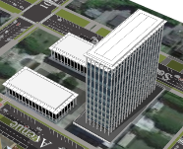

The Government Center has two wings that house the Juvenile Court, its clerk's office, Human Resources Department, the District Attorney's Victim-Witness Office, and additional space for the Marshal's Office. Note that both the District Attorney’s Office and Marshal’s Office functions are divided among floors and buildings – as are the functions of other offices at this location – in order to accommodate their respective missions and growth.

With funds from the 2009 Special Purpose Local Option Sales Tax (SPLOST), the City Services Center was constructed on Macon Road and opened in 2013. The City Services Center currently houses the Tax Assessor’s Office, Tax Commissioner’s Office, Council Chamber for Council Meetings, and other offices that were moved from the Government Center to provide those departments with more space and a central location for citizens’ non-judicial needs. Abandoned space was quickly filled with the pressing needs of the remaining offices and functions. The assignment of this abandoned space was an effectuated pursuit to a space reallocation effort conducted by CCG and its consultants for maximum efficiencies given the existing limitations of the Government Center.

Existing Conditions and System Concerns
A Property Condition Assessment identifies the existing site, as “a raised podium with a 12 level tower on the south end and two three level wing buildings on the east and west sides.” (SeeAppendix D.5, Property Condition Assessment pg.5). The site also contains a three (3) level parking deck for government personnel use. Both the main tower and the corresponding wings use similar designs, “consisting of a reinforced concrete frame supported by a caisson foundation, with perimeter cast-in-place reinforced concrete podium walls supported by concrete spread footings and smaller caissons”. Id.The exterior design of the building “is dark colored anodized aluminum curtain wall extending between exposed continuous exterior columns at 48 bays around the perimeter”, consisting of window “groups of two units 3’-3” wide separated by a 4' wide unit all 6’ high mulled in groups of three at each bay around the perimeter of each floor”, which make the exterior energy inefficient.Id.Though the existing structure does show signs of wear and tear, cracking and water infiltration, the overall structure of the building itself is in fair condition.
However, the existing systems in the Government Center range from fair to poor condition. The cooling and heating systemswere both identified as being in fair condition and seem to have the capacity to maintain the current structure, but are noted to be highly inefficient.Bothsystems have efficient capacity, but present serious corrosion issues throughout the entire structure. (See Appendix D.6,pg. 35-39,Hot Water Heating Piping System Concern). These corrosion issues create significant safety concerns for the employees and the general public who visit the facility on a day-to-day basis. The temperature control system is in poor condition due to multiple component failures. (Id. pg. 43). These component failures, along with the energy inefficient exterior wall of the existing structure, make temperature control throughout the building difficult and uncomfortable. Regularly, occupants on one side of a Government Center floor experience 56 degree temperatures and run space heaters and utilize lap blankets to keep warm, while simultaneously the occupants on the other side of the floor experience temperatures above 80 degrees.
The Commission toured the facility and heard presentations that further detailed its security and safety threats, as well as the threats of systems failure:
- Security and Safety Threats
Major Mike Massey of the Sheriff’s Office reported to the Commission on safety issues that threaten law enforcement, the public, judges, prosecutors and attorneys. The world has changed since the Government Center’s 1969 construction, and the security needs for government and court facilities have changed with it. Government Center security changed drastically due to the events like September 11, 2001, which in turn drastically altered the intended functionality of the building.
Security problems now exist that were unforeseen or unaccounted for during the facility’s 1969 construction, as underscored in the 2005 murder of Judge Rowland Barnes in open court in Fulton County, Georgia. Prisoners are frequently transported from the Muscogee County Jail in large numbers to an open and unsecured location in the parking garage, then transported to a holding area in the Sheriff’s Office and then to court. Too often prisoners, other accused and their families and associates are in immediate contact with the prosecutors, judges, jurists and victims involved in their criminal cases.Major Massey additionally reported that the parking garage is not secure, putting judges and prosecutors in danger. Although there are four elevators in the tower for employees and citizens, there is only one private elevator available for judges. Remarkably, this elevator is also the only one available for prisoner transport, and judges often ride with prisoners who may be on their way to sentencing or trial.
Child Custody, Divorce, Drug Courts, Juvenile and Mental Health cases also are heard in cramped quarters, where witnesses, victims, defendants and family members are thrust together in public corridors resulting in volatile outbursts and physical altercations.
Two 20-person holding cells for prisoners on the Fourth Floor present notable problems for the Sheriff’s Office. The tight primitive confines are a safety threat and can seriously undermine court proceedings if defendants and witnesses are allowed to be in the same vicinity. In these situations, it often becomes necessary for prisoners to be moved from the holding area to open hallways where deputies are is assigned to monitor them until their cases are called, preventing the deputies from attending their regular duties.
Other graveconcerns relate to the safety of the building occupants and the public at large. There is a fire suppression sprinkler system on the first floor only, and Fire Department ladders can reach no higher than the fifth floor, endangering all, but particularly endangering anyone located on the higher floors of the building. With the current fire stair design and lack of an accompanying suppression system, and because the stairwells are not self-contained, smoke would be sucked into the escape stairs posing a risk of asphyxiation. This condition actually occurred in the 1990s when a smoke bomb was ignited on the fourth floor of the Government Center.The stairs are narrower than necessary for equipment-laden firefighters to climb while employees and members of the public attempt to descend to escape fire or smoke.Though standard in buildings constructed in the past few decades, the Government Center stairwell does not have “safe spaces” for slower moving evacuees to stand to the side to catch their breath while allowing others to more swiftly pass. The lack of such safe spaces in the stairwells increases the likelihood of congestion, panic and trampling. The stairwells empty to the middle of the Government Center building ground floor, which actually is below ground – like a basement – and has limited and bottle-necked egress. A recent unplanned fire alarm and relatively well-executed evacuation of the Government Center demonstrated that under the conditions of an actual fire with moderate to heavy smoke, the results would likely be catastrophic with injuries and the real possibility for the loss of life.
Because the exterior doors in the Wings had to be closed off after new security procedures were adopted following the terrorist attacks in New York on September 11, 2001, some emergency exit routes actually end up back inside the building rather than outside. Whereas, citizens could previously enter the facility from open-area steps leading up to the plaza level and also at entrances at the wings, security required ingress and egress to be consolidated, and thus was limited to the entrance on the ground floor south side breezeway, and the other entryways were closed off. Major Massey reported on this challenging arrangement where the public must enter through the only secure area - the basement, backside of the tower. Besides the confusing and ungainly path visitors must take to enter the Government Center to do business, the Sheriff’s Office is challenged to maintain orderly and secure egress through this awkward bottleneck. It was pointed out that this arrangement was quickly put in place after September 11: what was then a temporary solution became permanent. Commissioners and a public survey noted that this backdoor entrance to Columbus’ most prominent civic building is far from desirable.
- Systems Failures
Commissioners were given tours of the facility’s tower and wings, where they reviewed a variety of facility systems problems. The building is completely clad in glass that is not insulated resulting in an interior environment which, as noted above, is so cold on one side of the structure that employees must utilize additional electricity to run space heaters, while theHVAC running a full tilt cannot alleviate theunnaturally hot condition on the other side. The HVAC system cannot compensate for this wide fluctuation in temperature because of the glass.
Public Works Director Pat Biegler and Inspections and Code Director John Hudgison presented the Commission with an overview of the Government Center’s current condition based on a 2013 study. While the structure itself is generally sound, HVAC systems are inefficient and overworked due to uninsulated windows, there are no fire sprinklers above the first floor, the elevator systems break down regularly, the emergency generator is inoperable and there is a wide range of safety and code violations. The design of the building prevents maintenance personnel from accessing many of the building’s electric and plumbing shafts. Much of the building is not ADA compliant, particularly includingrestrooms. Recently, the son of a disabled women alerted Government Center office staff that his disabled mother had gone into the non-ADA compliant women’s restroom, became stuck, and was requesting female assistance. A female Administrative Assistant, untrained in the care of disabled individuals, rendered compassionate aid to assist the disabled citizen. Our citizens deserve a higher level of dignity than the Government Center facilities offer, regardless of their physical limitations.
A serious and immediate systems and safety issue was brought to the Commission’s attention regarding the building’s hot water heating piping system. (See Appendix D.6, Hot Water Heating Piping System Concerns). Leakage in the Government Centers piping system was first discovered in the East Wing on February 8, 2017.Id.Government Personnel indicated that the overall difficulty to repair these corroded pipes could run throughout the entire facility, which is a serious issue because the facility has over 600 heating terminals. Id.The City Manager illustrated the danger of this issue to the Commission by explaining that the temperature of the water passing through these pipes is more than 140 degrees and could seriously injure a person on contact. Both long-term and short-term solutions to the piping issue were listed in the presentation, with the long-term solution being estimated as around $1.7 million. Id.Council has appropriated these otherwise unbudgeted funds in order to immediately remediate this situation. This expenditure is just one costly example of the ever-increasing frequency of significant costs associated with the maintenance of a building the systems of which are aging and failing.
The energyback-up systems utilized by the facility originally consisted of “a single diesel powered emergency generator, reinforced concrete columns and floors, reinforced cast-in-place concrete walls, drywall partitions, enclosed exit stairs with the rated assemblies created using the fire suppression system and two-hour rated partitions”. The original emergency generator located in the basement of the Government Center is no longer functional, and it cannot be removed from the facility due to its size, and above described constructed location. As a result, the replacement generator (which is the size of a trailer) had to be located on the exterior of the building blocking a public sidewalk and parking spaces.

Space Needs Assessment
The Commission was informed that a Space Needs Assessment had been conducted in 2014 in conjunction with the move of some CCG services to the City Services Center. It was noted that an update of that assessment was needed before moving forward with refined proposals for a renovated or a new Government Center.
On June 26, 2017, Inspections and Code Director John Hudgison presented the City’s Needs Assessment Update. Mr. Hudgison’s report systematically evaluated each non-judicial department separately to establish square footage needed and included projected future needs. (See Appendix D.16, Non-Judicial Space Needs Assessment). An additional amendment was made to this report on August 30th, 2017. Id.

Renovation Versus New Construction
A consistent inquiry in the early deliberations of the Commission related to the options of either renovating the Government Center structure, or demolishing the existing structure and building a new structure. Thethree initial, ballpark options reviewed were as follows:
Option 1 – Renovation of Tower and Wings, plus a new five story Tower Addition. Judicial and Governmental programs are comingled throughout the complex. Renovation of existing parking deck. A new 9th Street parking deck. Estimated construction cost is $98,919,000 with an additional $9,891,900 in inflation costs if needed to extend the beginning of construction to 2023.
Option 2 – Renovation of Tower only, plus a new three story Tower Addition to house the judicial program. A separate new building to house general governmental functions. A new underground parking deck on site, and a new 9th Street parking deck. Estimated construction cost is $102,709,200, with an additional $10,270,920 in inflation cost if needed to extend the beginning of construction to 2023.1
Option 3 – A new building to house the judicial functions. A separate new building to house the general governmental functions. A new underground parking deck on site, and a new 9th Street parking deck. Estimated construction cost is $110,833,200, with an additional $11,083,320 in inflation cost if needed to extend the beginning of construction to 2023.1
The Muscogee County Jail is currently located at 700 - 10th Street, several blocks away from the Government Center. At each step in this process, the option of building the Judicial Center adjacent to the jail was considered. After study, it was determined that the available footprint of the jail property located in the Liberty District is not large enough for the construction of a judicial center building.

Architectural and Historical Significance of the Government Center
Director of Historic Columbus Elizabeth Barkerprovided Commission members with a presentation regarding the architectural value of the existing Government Center.(See Appendix D.10, Historic Columbus Presentation). Government Center architecture isa mixture of both International and Brutalist designs. The center tower represents a strong style of Brutalism by its use of repetition, while the wings of the structure represent a sense of International design due to their use of the exterior pillars located all around the building.
Historic Columbus announced its position that the Government Center should not be demolished, but that thebuildings should be renovated, or reused for purposes other than governmental or judicial functions. (See Appendix D.11, Historic Columbus Foundations Publicized Position Statement).
Proposed Funding Options
Finance Director Angelica Alexander gave a presentation on funding options for the new or renovated Government and Judicial buildings. Ms. Alexander identified four options for financing construction of the facility:

1. Special Purpose Local Option Sales Tax (SPLOST)
2. General Obligation Bonds
3. Brick and Mortar Financing Program through Georgia Municipal Association
4. Developer Financed Lease-Purchase
SPLOST is an option that proposes to increase the local tax rate by 1% or 1/100 of a dollar. This plan is capable of generating approximately$33 million a year based on current collections at 1% (See Appendix D.12, Funding Options). This plan would allow the city to pay for the proposed structure within 5 years. Currently Sales Tax in Columbus, Georgia is 8%; 4% State Tax, 1% City LOST (does not expire), 1% City OLOST (does not expire), 1% School District ESPLOST (expires 6/30/2020), 1% City TSPLOST (expires 12/21/2022). Id.
Once the ESPLOST program expires in 2020, the City could initiate a SPLOST ballot initiative without changing the current tax rate. It was noted that this could be one of the more desirable options, in that the community would have to approve it through a vote and in that the community is already accustomed to the current 8% tax rate. SPLOST funding is also beneficial becauseit prevents the local community from bearing 100% of the absolute cost. A SPLOSTreaps the benefit of visitorspending within our community and those funds from non-residents wouldassistin paying for the proposed structure. This visitor contribution would help relieve some of the Columbus communityfinancial burden. In other words, a SPLOST allows a percentage of the building funding to come from an outside source rather than being produced solelyby Columbus, Georgia residents.
General Obligation Bonds are bonds issued by a local government as financing mechanisms for authorized governmental projects. Id. These bonds are a form of debt and are backed by local tax revenues for the payment of the principal and interest due on these bonds. This option could be funded by the passage of a SPLOST tax as discussed above. Otherwise, the servicing of the bonds would have to come from existing CCG funding such as the already overburdened General Fund revenues.
Brick and Mortar Financing Programs of the Georgia Municipal Association (GMA) are programs specifically formed to facilitate financing for long term real estate projects (renovation and/or new construction). These program terms can range from 5 to 30 years in length and are subject to certain limitations and special requirements. Id.
Developer Financed Lease-Purchase is the final funding option available for the Commissions’ consideration. In this option, a third party acquires the property and makes it available to the City in return for incremental payments consisting of principal and interest (SeeAppendix D.12, “Funding Options”). The principal amount of the lease-purchase contract will be the acquisition and/or construction price of the property, and interest will be determined by mutual agreement and based on market conditions. Id.
There was general consensus that issuance of general obligation bonds, serviced through a SPLOST ballot initiative, was the best option and would be a recommendation of the Commission.

Conceptual Site Studies
The Commission reviewed several initial site locations and layouts in the“Conceptual Site Studies” (See Appendix D.13, D.15 and D.20, Conceptual Site Studies). These presentations proposed four(4) purely conceptual site plans for the Commission to examine and discuss. These plans were strictly identified as “conceptual ideas” and were presented to provide Commission members with visual concepts of options available for discussion and ultimately for their consideration.
Option A proposed constructing a five(5) story judicial building next to the Jail, located at700 E 10th St, Columbus, GA 31901, and parking deck (next to the existing recorders court). In this option, each wing of the current Government Center would be demolished but the tower would be maintained and refurbished for further operational use. This option allowed for the administrative and judicial branches to be separated, while preserving the original tower design. This option added a large green space for public use and activity. Id.
Option B proposed constructing a five story judicial building anext to the Jail, located at 700 E 10th St, Columbus, GA 31901, and parking deck (next to the existing recorders court, as well). In this option, both the tower and wings would be refurbished for future operational use and could either be resold or reused for administrative purposes. Id.
Option C proposed constructing a seven(7) to eight (8) story judicial building on the current Government Center site, directly across from the existing tower. In this option, the current Government Center tower would be refurbished for reuse but both wings would be demolished and a connecting structure would be built on one side to connect the two larger structures. Option C would create a large green space for public use and activity. Id.
Option D proposed adding two lower level structures, in an L shape design, to the existing Government Center tower specifically for judicial use. This option allows the current tower to be refurbished for reuse, while moving the courts to the lower level structures to free up elevator space for employee and citizen use. Option D would create a large green space for public use and activity. Id.
Commissioners discussed the four concepts and debated the strengths and weaknesses of all options. Modifications were proposed to strengthen each. Eventually, a consensus emerged that a separate judicial function would eliminate many of the current operational and safety problems. It was pointed out that the current Government Center was designed to hold six courtrooms and that, presently, there are now eleven courts. The issue of future growth in the courts was brought up again and discussed. Commissioners agreed that planning for growth was essential.
In response to Commissioners’ feedback to the Conceptual Site Studies presented at the May 22ndmeeting, Neil Clark of Hecht-Burdeshaw presented three additional options, noting that the options could change upon the incorporation of future CCG’s space needs data:
Option E: New Judicial Center and new Government Operations structure on the existing site. A parking deck would be built across 9th Street to the South.
Option E.1: A single structure built roughly 9-10 stories tall with judicial functions on the first 5 floors and non-judicial function on the remaining floors above. Parking deck across 9th Street.
Option F: A smaller single building on the existing site for general government services and a separate Judicial Building on a new site closer the jail. This would allow non-judicial functions to remain on the current site and provide a large green space for public use and activity.

Initial Citizen and User Input.
The Commission hosted two (2) publictours of the Government Center on Wednesday, July 26th, from 5:30-6:30 pm.The Government Center tours were led by John Hudgison, Director of Building Codes and Inspections for CCG, Johnny Harp, Facility Maintenance Manager, and Lt. Brad Hicks, from the Muscogee County Sheriff’s Office. These tours introduced the citizens to some of the most troubling issues of the existing structure, along with the safety concerns. Each tour was filmed by local media and CCG-TV and was aired by each organization for those citizens who could not make the actual tour. In particular, CCG-TV ran the filmed tour roughly four (4) times a day for over two (2) weeks to ensure that every member in the community had an opportunity to observe the tours. A link to one of the recorded tours was also posted on CCG’s website and Mayor Teresa Tomlinson’s three FaceBook pages.
A Survey Sub-committee of the Commission was formed to design and publish surveys seeking community input. An Initial Public Survey was published seeking general input regarding the community’s use of and impression of the existing Government Center.
Commission sub-committee member David Helmick made a comprehensive presentation on the Initial Public Survey which was distributed by email, social media and links associated with newspaper articles. A total sample of 1,570 surveys were returned and thousands of comments were added. There was wide age distribution with participating citizens ranging from 12 to 70 years old. (See Appendix E.1, E.2 and E.3, Commission InitalPublicSurvey).
Over fifty percent of the public expressed dissatisfaction with the existing conditions of the facility, and supported a judicial facility that is separate from general government functions. Citizens noted the lack of fire suppression, slow elevators, and poor emergency exits as primary concerns. Nearly fifty percent of survey-takers responded that the facility was an important icon or symbol of Columbus, Georgia, although several individuals noted in their comments that it was an icon for negative and undesirable reasons, includingthe fact that the Government Centeris taller than the buildings in its area.
Other findings of the Initial Public Survey were as follows:
- 33.81% of the citizens that took the survey stated that they occasionally visit the Government Center (once every year or two). Id.
- A majority of the citizens (over 68.91%) taking the survey knew that the Sheriff’s Office, Judicial/Courts, and Public Records are housed in the Government Center.Id.
- A majorityof the citizens (50.74%) that took the survey were dissatisfied with the parking at the Government Center. Id.
- A majority of the citizens (54.65%) taking the survey were satisfied with the security screen process at the Government Center, though the comments suggest the respondents are satisfied with the Sheriff’s handling of the security screen process not with the layout or functionality of the process. Id.
- Many of the citizens (43.98%) taking the survey were dissatisfied with the layout and design of the Government Center. Id.
- A majority of the citizens (51.26%) taking the survey were dissatisfied with the Government Center facilities (elevators, stairwells, restrooms, hallways, etc). Id.
- Many of the citizens (38.65%) taking the survey weresatisfied with the Government Centers amenities (Plaza level, courtyard, war memorial, public gathering areas, etc.)Id.
- Many of the citizens (44.18%) taking the survey were neutral or had no opinion on the accessibility of the Government Center for citizens with disabilities. Id.
- A majority of the citizens (60.73%) taking the survey were satisfied with the sense of security and safety within the Government Center, though again the comments suggest this is satisfaction with the Sheriff’s Office. Id.
- The top four (4) concerns citizens taking the survey had about the Government Center were elevator issues (65.62%), lack of fire suppression systems (47.28%), corrosion of cooling systems pipes (45.34%), and lack of emergency exits (41.26%).Id.
- Citizens taking the survey were equally satisfied and dissatisfied with the Government Center (41.5% Satisfied, 42.63% Dissatisfied). Id.
- 49% of the citizens taking the survey thought the Government Center was an important icon, 38.84% stated it was not an important icon and 14.16% had no opinion. Id.
- 47.31% of the citizens taking the survey thought the Government Center should be preserved and maintained, 39.21% thought is should not be preserved and maintained, and 13.48% had no opinion. Id.
- A majority of the citizens (50.47%) taking the survey believe that the Judicial Complex should be housed separately from the general government facility. Id.
After the conclusion of the Initial Public Survey, a Commission Member Survey was conducted to narrow the previously discussed Site Concepts for further analysis and review. This survey was only provided to Commission members and not to the general public. (SeeAppendix E.6& E.7, Commission Member Initial Survey). The results of that survey were as follows:
- A supermajority (90.48%) of the Commission members who voted agreed that the Government and Judicial branches should be located in different buildings. (See Appendix E.6&E.7, Commission MemberInitial Survey)
- A majority (52.38%) of the Commission members who voted had no opinion on whether or not these two (2) buildings should be located on the same or different sites. Id.
- Exactly 50% of the Commission members who voted agreed that the existing tower of the Government Center should becompletely torn down, while 15% voted that it should be kept but completely gutted and 35% voted that it should be kept and only major systems renovated. Id.
This survey was intended to gauge key issues still facing the Commission for consideration.The Commission was in agreement on the concept of two separate buildings (Government and Judicial), which was also supported by the public with well-over 50% of the vote going for the separate facilities. Id.The Commission voted 19 for, 1 against, with 1 abstaining. From these findings the volunteer architects assisting the Commission devised three building proposals to narrow the Commission focus and provide more in-depth analysis of the options.

Three Building Proposals
On August 30, 2017, a more refined set of the Conceptual Study renderings were presented to the Commission by Scott Allen and Michael Starr of 2WR+Partners and Tim Jensen and Neil Clark of Hecht-Burdeshaw Architects. It was reiterated to Commissioners that these drawings were still conceptual in nature and may not resemble the final design.
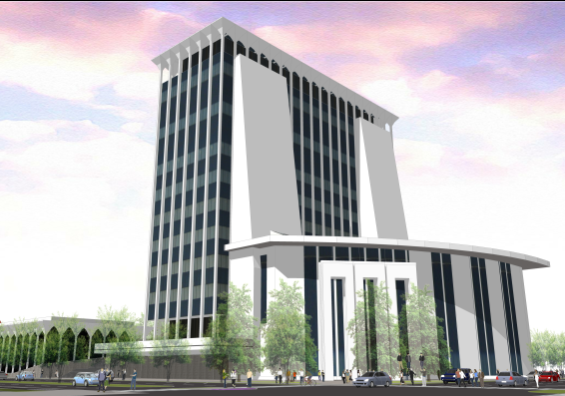
Scenario 1 proposed both wings and the tower be kept but renovated. This scenario projected cost at roughly $109,764,900, excluding whitebox space costs for additional growth.

 | Area | @ | =
Demolish (Selective) Tower | 202,800 SF | $5 | $1,014,000
Demolish (Selective) Wings | 72,600 SF | $5 | $363,000
Demolish Parking Deck | 0 Spaces | $5,000 | $0
Renovate Tower | 202,800 SF | $195 | $39,546,000
Renovate Wings | 72,600 SF | $175 | $12,705,000
Tower Addition | 118,000 SF | $300 | $35,400,000
New Building for City Offices | 0 SF | $200 | $0
Existing Parking Deck (Underground) | 145 Spaces | $4,000 | $580,000
New Parking Deck (Above Ground) | 555 Spaces | $15,000 | $8,325,000
Site and Landscaping |  |  | $2,000,000
Subtotal Cost |  |  | $99,933,000
Increase for Time through 2023 |  |  | $9,891,900
Total Demolition/Construction Estimate |  |  | $109,764,900

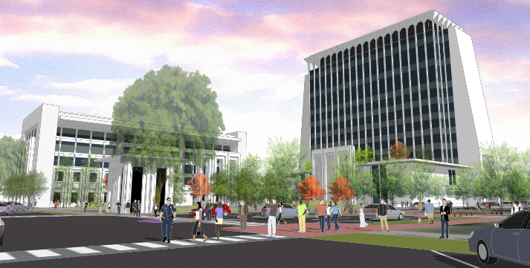
Scenario 2 retains the existing tower, but renovates it for judicial use, demolishes the wings and builds a new multi-story building for non-judicial government use. Again, in this plan, the lower level of the tower would be expanded and the tower would be assigned a pure judicial function. This scenario was projected at a cost of $113,994,120, excluding whitebox space cost for additional growth.

 | Area | @ | =
Demolish (Selective) Tower | 202,800 SF | $5 | $1,014,000
Demolish Wings | 72,600 SF | $7 | $508,200
Demolish Parking Deck | 145 Spaces | $5,000 | $725,000
Renovate Tower | 202,800 SF | $195 | $39,546,000
Renovate Wings | 0 SF | $0 | $0
Tower Addition | 88,100 SF | $300 | $26,430,000
New Building for City Offices | 102,500 SF | $200 | $20,500,000
New Parking Deck (Underground) | 300 Spaces | $20,000 | $6,000,000
New Parking Deck (Above Ground) | 400 Spaces | $15,000 | $6,000,000
Site and Landscaping |  |  | $3,000,000
Subtotal Cost |  |  | $103,723,200
Increase for Time through 2023 |  |  | $10,270,920
Total Demolition/Construction Estimate |  |  | $113,994,120

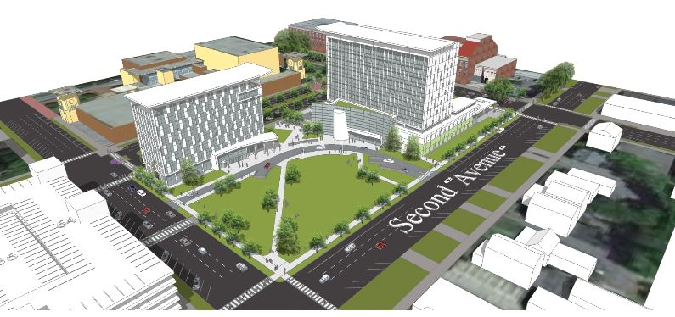
Scenario 3 proposes a complete demolition of tower and the wings with two new multi-story buildings constructed for separate general government and judicial functions. The approximate cost of this scenario is $123,944,520, excluding whitebox space cost for additional growth.

 | Area | @ | =
Demolish Tower | 202,800 SF | $10 | $2,028,000
Demolish Wings | 72,600 SF | $7 | $508,000
Demolish Parking Deck | 145 Spaces | $5,000 | $725,000
Renovate Tower | 0 SF | $0 | $0
Renovate Wings | 0 SF | $0 | $0
New Judicial Building | 260,000 SF | $285 | $74,100,000
New Building for City Offices | 102,500 SF | $200 | $20,500,000
New Parking Deck (Underground) | 300 Spaces | $20,000 | $6,000,000
New Parking Deck (Above Ground) | 400 Spaces | $15,000 | $6,000,000
Site and Landscaping |  |  | $3,000,000
Subtotal Cost |  |  | $112,861,200
Increase for Time through 2023 |  |  | $11,083,320
Total Demolition/Construction Estimate |  |  | $123,944,520

All three scenarios assume the cost of a new parking deck across 9th Street for public and employee use. Additionally, an amended Space Needs Assessment was submitted to theCommission which identified the slight need for space refinement in each of the three proposals, but nothing material to the conceptual analysis of the three proposals was noted.
Given the identified energy inefficiencies of the existing Government Center, Mr. Clark presented an Energy Assessment Study including HVAC, lighting, exterior envelope and control, which projected a $1.99 per square foot daily cost compared to the current $2.49 per square foot daily cost for the existing Government Center Tower and Wings. This would result in hundreds of thousands of dollars in efficiency cost savings.
The current energy costs for the existing Government Center is $690,171 annually. A complete renovation of the existing building, evenwith an additional 24% more space, would create an annual savings of roughly 24% - 34% on energy cost alone. A newly constructed Government Center, evenwith an additional 13% more space, would create an annual savings of roughly 33% - 42% on energy cost.

Potential Energy Savings:
Renovations w/ Addition Estimate | Complete New Construction Estimate
$450,000 - $520,000 Electrical Cost | $400,000 - $460,000 Electrical Cost
24% - 34% Savings ($165,000- $235,000annually) | 33% - 42% Savings ($227,000 - $290,000 annually)
24% More Space | 13% More Space
The energy and maintenance savings is significant and should be taken into consideration when weighing the net cost of renovation or new construction. Clearly, hundreds of thousands of dollars in energy costs and millions of dollars averted in imminent, necessary systems and other repairs to the Government Center will greatly reduce the net cost of each of the three proposals.

Public Forums
Once the three core options were identified and refined by the Commission, Public Forums were held throughout the community.Four public forums were held Tuesday, Sept. 19, 5:30 to 7 p.m., at the following locations:
• Government Center (Plaza Level), 100 E 10th Street
• Citizen Services Center (Community Room), 3111 Citizens Way
• Frank Chester Rec Center, 1441 Benning Drive
• Psalmond Rd. Rec Center, 6550 Psalmond Road
City staff and volunteer architects presented each of the three concepts to those attending for their review, comments and questions. The public was given the opportunity to comment on these presentations by filling out forms distributed at the forums. (See Appendix F, Citizen Comment Cards)
In addition, a Commission Members Final Survey was published, providing a link to the building tour video mentioned above and providing the three options identified by the Commission, including estimated cost information. (See Appendix E.9 & E.10, Commission Members Final Survey).
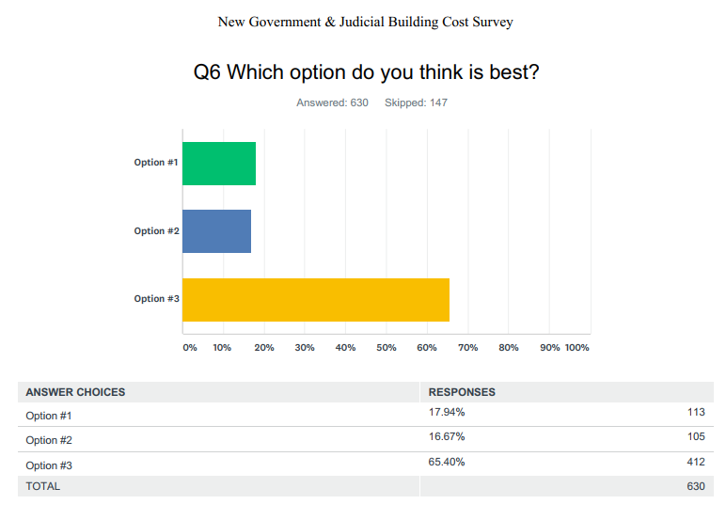
In conclusion, the final survey presented to the public identified to the Commission that the greatest public support is for option #3 with over two/ thirds (2/3) of the votes (65.40%) choosing this scenario as the most desirable of the options presented.

Commission Selection of Proposed Option
After numerous Commission meetings and after reviewing the Building Commission Report, each Commission member was provided a link to cast their final vote on the three (3) proposed scenarios. All but one (1) member of the Commission cast their vote. The results were as followed (See Appendix E.7 & E.8, Final Commission Member Survey):
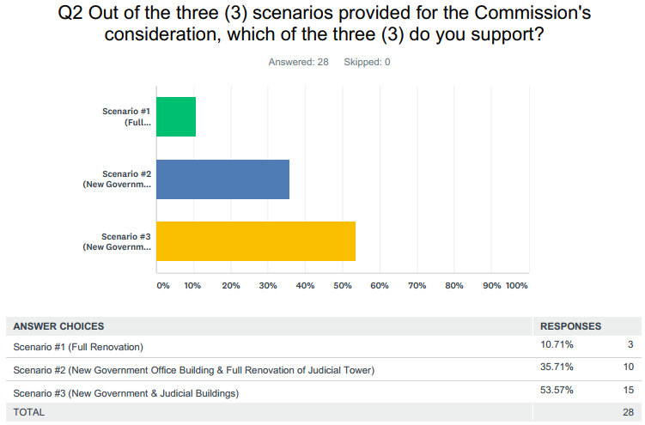
*Two Ex Officio (non-voting) members erroneously voted in the survey. Their votes have been removed to make the final tally as follows:

SCENERIO | COST | VOTE TOTAL
SCENARIO 1 | $109,764,900 | 3
SCENARIO 2 | $113,994,120 | 9
SCENARIO 3 | $123,944,520 | 14

Accordingly, it is the recommendation of the Commission that Council pursue Scenario #3, and fund the option through a SPLOST in 2020 when the current school district SPLOST expires. That will continue the sales tax rate in Muscogee County at 8% and will allow the citizens to vote on this project, perhaps in conjunction with other much needed capital projects for our community.
In addition, the Commission notes that there have been several opportunities for CCG to purchase existing office space for general government use. Though the Commission is concerned that any purchase of existing office space for general government use be functional, secure, and safe, as well as convey a level of civic dignity worthy of our citizens, such an opportunitywould provide for a lessen capital outlay and still provide for a new Judicial Center. Most general government functions do not have the security and other construction requirements of a Judicial Center, so that the segmenting of the remaining general government operations presently in the Government Center into existing office space could be a viable, lower cost option.
This is the 2017 New Government & Judicial Building Commission Report submitted to Mayor Teresa Tomlinson this _ day of _______, 2017.

Appendix Content
Appendix A – Meeting Agenda
Appendix A.1 – February 9, 2017 Meeting Agenda
Appendix A.2 – February 21, 2017Meeting Agenda
Appendix A.3 – March 13, 2017 Meeting Agenda
Appendix A.4 – April 13, 2017 Meeting Agenda
Appendix A.5 – May 4, 2017 Meeting Agenda
Appendix A.6 – May 22, 2017 Meeting Agenda
Appendix A.7 – June 26, 2017 Meeting Agenda
Appendix A.8 – July 24, 2017 Meeting Agenda
Appendix A.9 – July 26, 2017 Meeting Agenda
Appendix A.10 – August 30, 2017 Meeting Agenda
Appendix A.11 – September 19, 2017 Meeting Agenda
Appendix A.12 – November 9, 2017 Meeting Agenda
Appendix B – Meeting Minutes
Appendix B.1 – February 9, 2017 Meeting Minutes
Appendix B.2 – February 21, 2017Meeting Minutes
Appendix B.3 – March 13, 2017 Meeting Minutes
Appendix B.4 – April 13, 2017 Meeting Minutes
Appendix B.5 – May 4, 2017 Meeting Minutes
Appendix B.6 – May 22, 2017 Meeting Minutes
Appendix B.7 – June 26, 2017 Meeting Minutes
Appendix B.8 – July 24, 2017 Meeting Minutes
Appendix B.9 – July 26, 2017 Meeting Minutes
Appendix B.10 – August 30, 2017 Meeting Minutes
Appendix B.11 – September 19, 2017 Meeting Minutes
Appendix B.12 – November 9, 2017 Meeting Minutes
Appendix C – Media Reports
Appendix C.1 – Columbus Mayor Creates Advisory Commissionfor New Government Center (WTVM)
Appendix C.2 – Mayor Weighs in on Aging Columbus Government Center Building (WTVM)
Appendix C.3 – New Columbus Government Center Could Cost $100 Million or More (Ledger-Enquirer)
Appendix C.4 – “Building should not be Demolished” Says Historic Columbus on Government Center (Ledger-Enquirer)
Appendix C.5 – Columbus Government Center Open House Tour Reveals Serious Issues (WRBL)
Appendix C.6 – Government Center Tour Shows Criminal Safety Concerns (Ledger-Enquirer)
Appendix C.7 – Mayor Tomlinson’s New Government Center Commission Schedules 4 Public Forums (Ledger-Enquirer)
Appendix C.8 – Mayor Releases Survey Asking for Public Opinion on Government Center (Ledger-Enquirer)
Appendix C.9 – Up Close look at three Government Center Proposals (WRBL)
Appendix C.10 – What’s Next for the Government Center? (Ledger-Enquirer)
Appendix D – Commission Reports & Presentation
Appendix D.1 – Government Center Space Needs Comparison
Appendix D.2 – Columbus Judicial System Needs
Appendix D.3 – Security & Safety Presentation
Appendix D.4 – Government Center Master Plan Presentation
Appendix D.5 – Property Condition Assessment
Appendix D.6 – Hot Water Heating Piping System Concerns Presentation
Appendix D.7 – Hot Water Heating Piping Systems Letter
Appendix D.8 – City Managers Email to Department Heads
Appendix D.9 – Option Proposals Presentation
Appendix D.10 – Historic Columbus Presentation
Appendix D.11 – Historic Columbus Position Statement
Appendix D.12 – Funding Options Presentation
Appendix D.13 – Conceptual Site Studies Presentation (1)
Appendix D.14 – Government Centers Non-Judicial Space Assessment
Appendix D.15 – Conceptual Site Studies Presentation (2)
Appendix D.16 – Government Center Non-Judicial Space Analysis
Appendix D.17 – Interview with Ed Neal, Architect for the Original Government Center
Appendix D.18 – Government Centers Judicial Space Assessment
Appendix D.19 – Energy Saving Assessment
Appendix D.20 – Conceptual Site Studies Presentation (3)
Appendix E – Commission Surveys
Appendix E.1 – New Government & Judicial Building CommissionInitialPublic Survey Results (Short)
Appendix E.2 – New Government & Judicial Building CommissionInitialPublic Survey Results (Long)
Appendix E.3 – New Government & Judicial Building Commission InitialPublic Survey Results Presentation
Appendix E.4 –New Government & Judicial Building Commission Final Public Survey Results (Short)
Appendix E.5 –New Government & Judicial Building Commission Final Public Survey Results (Long)
Appendix E.6 – New Government & Judicial Building Commission Initial Members Survey Results
Appendix E.7 – New Government & Judicial Building Commission Initial Members Survey Results Presentation
Appendix E.8 – New Government & Judicial Building Commission Public Survey Comparison Presentation
Appendix E.9 –New Government & Judicial Building Commission Members Final Survey Results Presentation
Appendix E.10 – New Government & Judicial Building Commission Members Final Survey Results Presentation
Appendix F – Public Comments

These estimated cost figures do not include additional 30,000 square feet of white-box growth space included in the final proposed cost. Seeinfra.
Should excess space be built for future growth, the architects suggest in this scenario an additional 31,200 square feet at $200 per square foot for an additional cost of $6.24 million. The Commission notes that Council previously declined to build whitebox space when constructing the City Service Center on Macon Road.
Should excess space be built for future growth, the architects suggest in this scenario an additional 30,000 square feet at $115 per square foot for an additional cost of $3.45 million. The Commission notes that Council previously declined to build whitebox space when constructing the City Service Center on Macon Road.
Should excess space be built for future growth, the architects suggest in this scenario an additional 30,000 square feet at $180 per square foot for an additional cost of $5.4 million. The Commission notes that Council previously declined to build whitebox space when constructing the City Service Center on Macon Road.
This figure includes $9,891,900 in projected inflation costs.
This figure includes $10,270,920 in projected inflation costs.
This figure includes $11,083,320 in projected inflation costs.

